Practical – 5
Name – Chetna Deshmukh
Section- A4
Roll No. – 24

Task 1
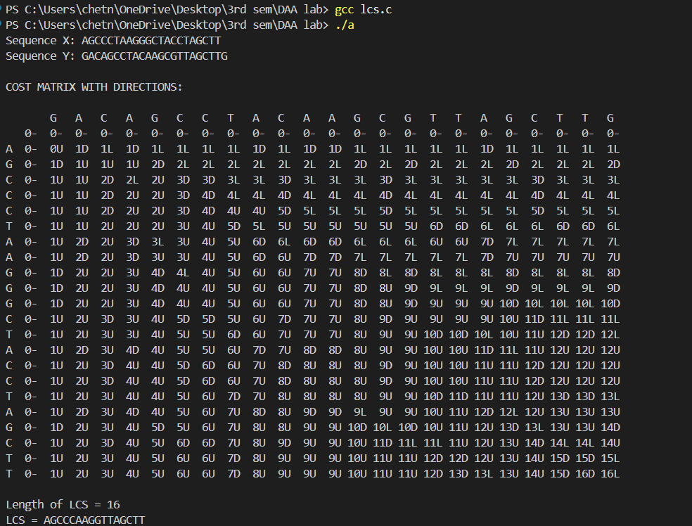

Task 2
